Logging on
- Go to 37281.afasinsite.nl.
The sign-on screen will be displayed.

(Select preferred language).
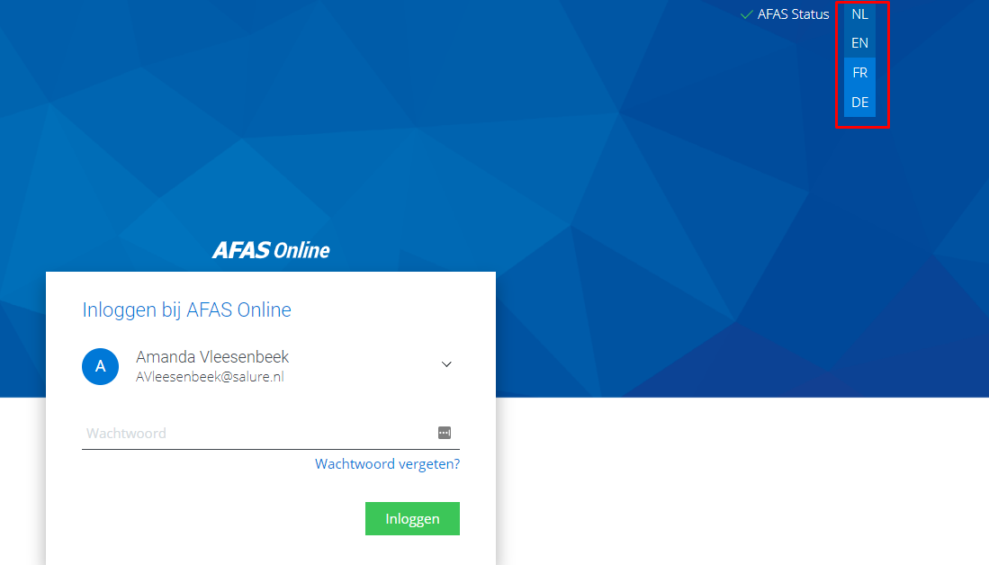

- Enter your private email address. In case you don’t have an email address at all, you need to create one. In case you need support, please contact the HR Back Office: hrnl@syncreon.com
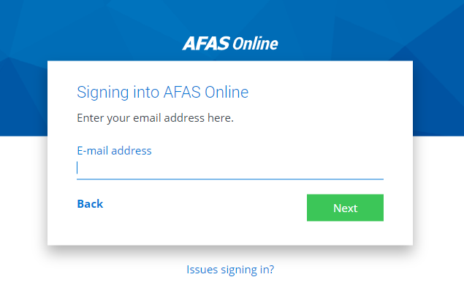
- Click Next.
- A message will be displayed that you have never signed on before.
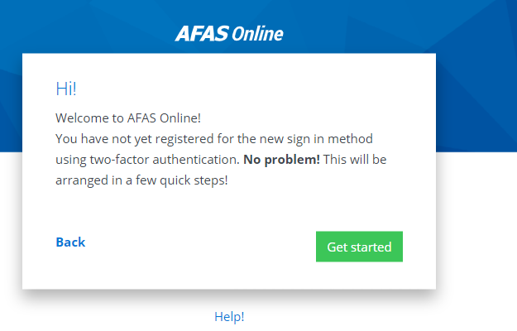

- Click Get started.
- You will receive an email message that will include a code.
- Enter the code on the portal page.
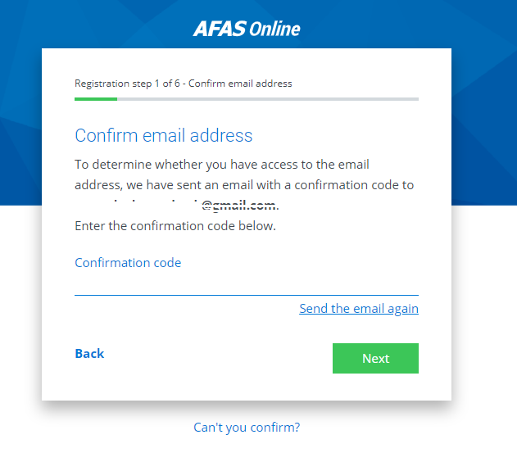

- Click Next.
- Enter a strong password.

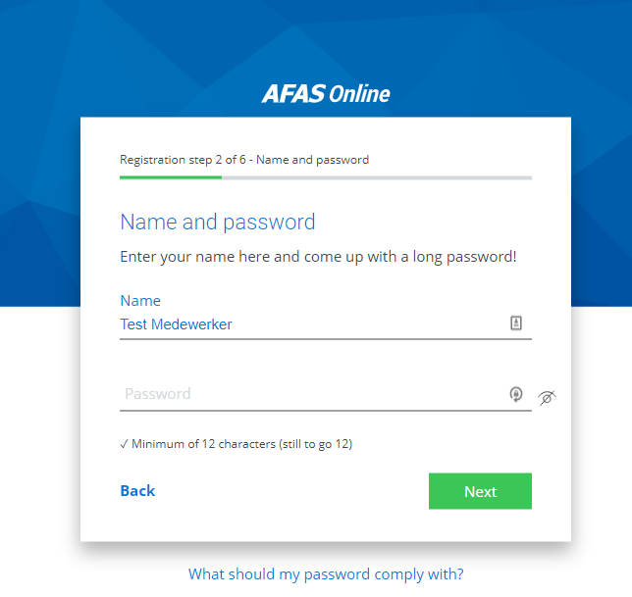

- Click Next.
- Enter your telephone number if it is not automatically displayed.
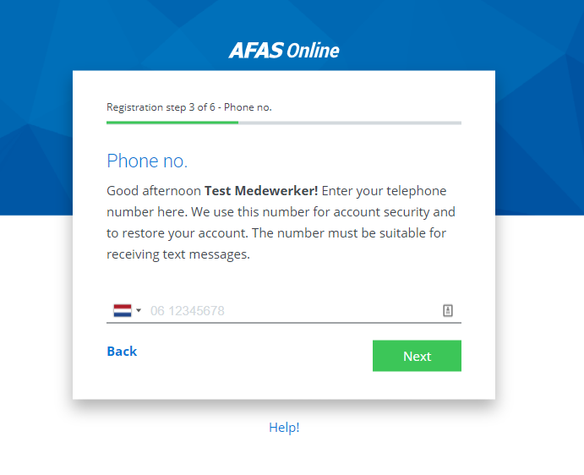

- Click Next.
- Confirm the text message code that you will receive through your telephone.

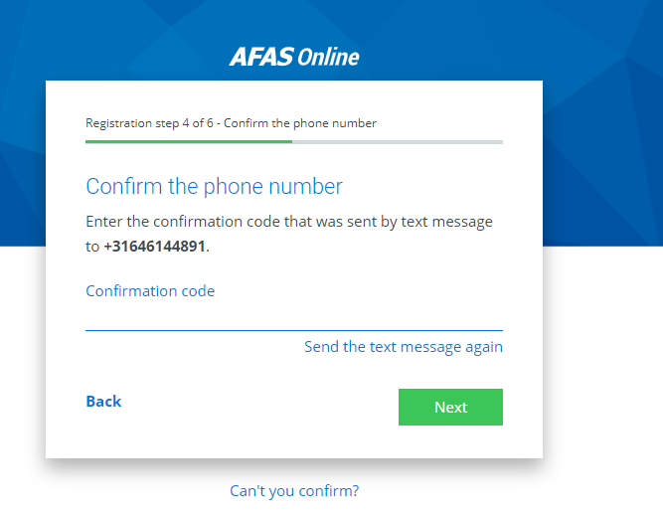

Install and link AFAS Pocket
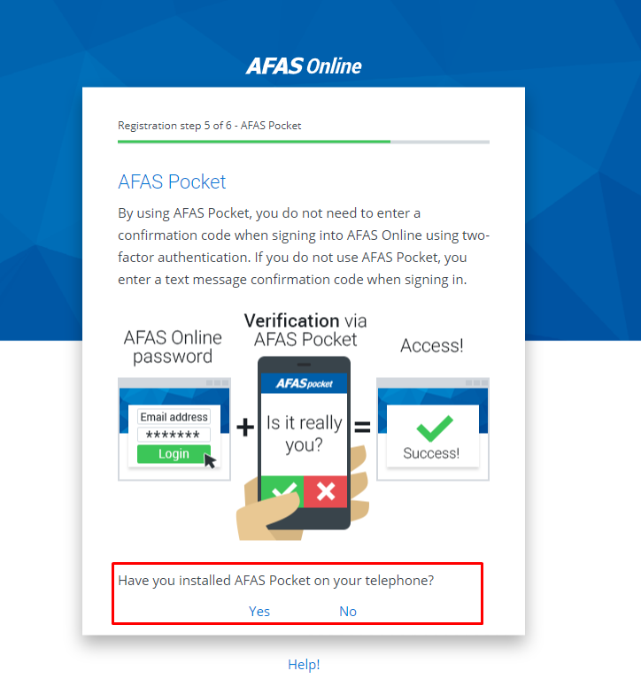
- You now have the following options:
  - Click Yes to link immediately. AFAS Pocket must, of course, be installed on your smartphone. Scan the QR code to link AFAS Pocket to your AFAS Online account.
Say that you have several AFAS Online accounts, you can then create this link for every account.

  - If you click No, you can still install AFAS Pocket and scan the QR code. See instructions in next screenshot:

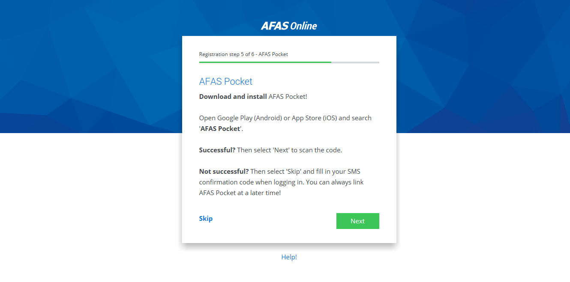
  - If you want to skip installing ‘AFAS Pocket’, click ‘Skip’. You will sign on in AFAS InSite using a confirmation code that you will receive through a text message.
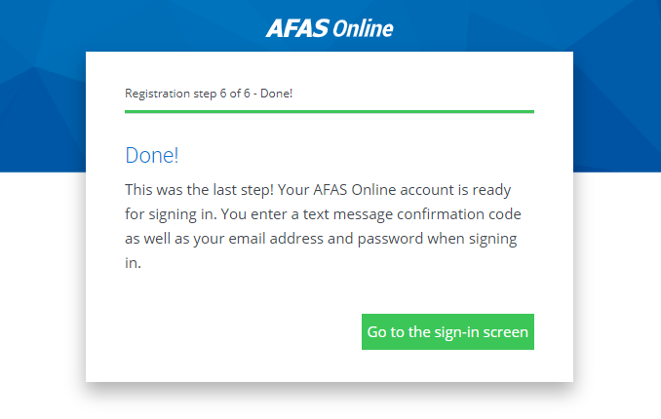
- If you have installed AFAS Pocket, click I have a QR code in AFAS Pocket

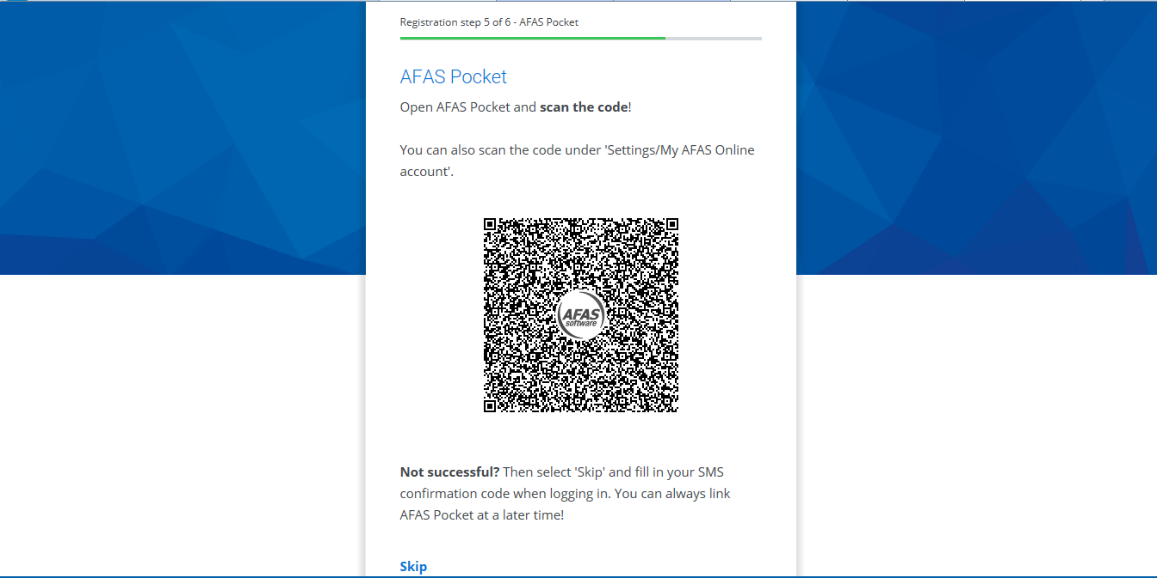
- Give your permission to use the camera and scan the QR code

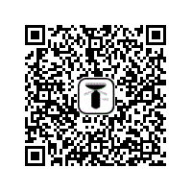

- If you have correctly scanned the code, a message will be displayed stating that your AFAS Online account has been linked to AFAS Pocket.

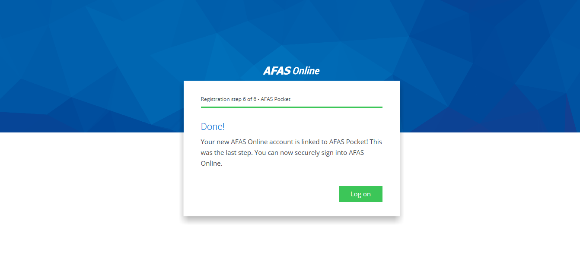
- Click Log on.

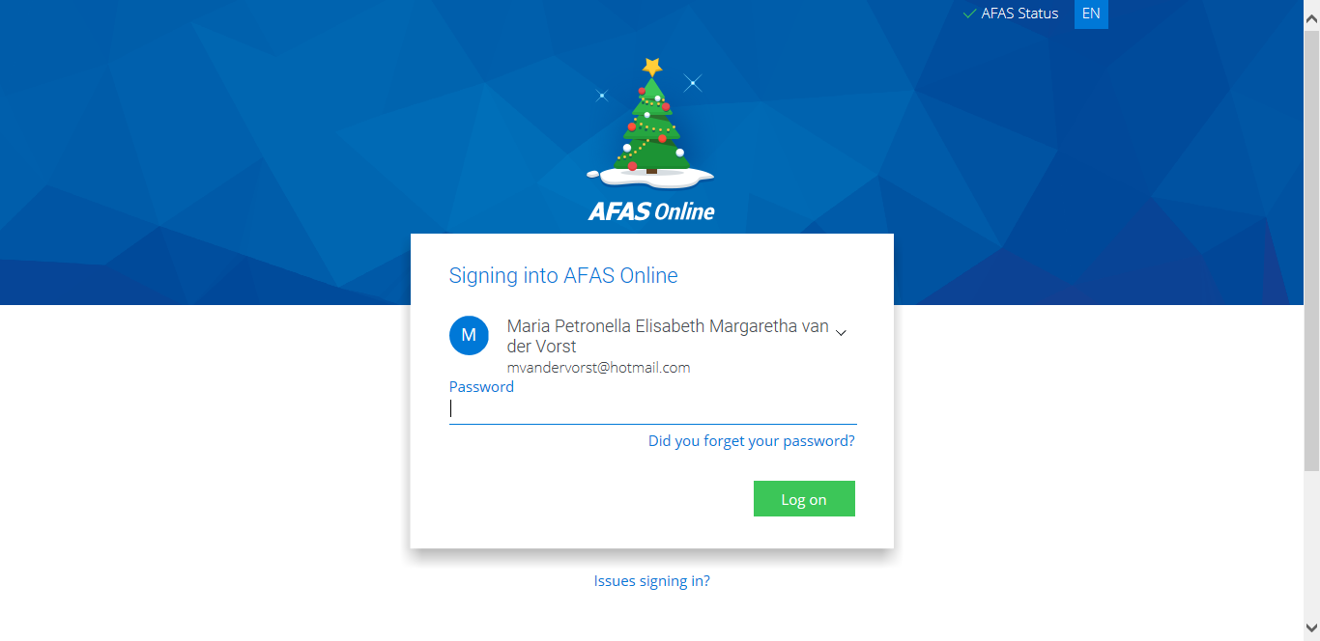

- You will receive a message on your smartphone to go to the AFAS Pocket app. Enter the app and click on the green button.
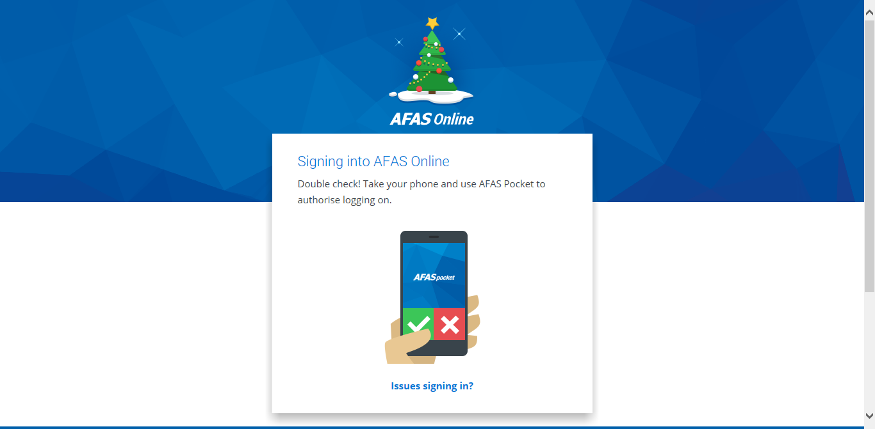

- You will now enter your personal AFAS InSite portal!
  - You will see it is your personal portal as the title is: Good morning/afternoon/evening <<Name>> and in the right upper corner it says: ‘Welcome <Name>’. Here you can also log off if you want to leave your personal portal.
  - On the right side of the portal you will see a list of colleagues who have their birthday that week.
  - At the bottom of the portal you will find your tasks and signals. It will give you an overview of your open, pending and completed requests.

